Thermal Cooking Handout

What is a Thermal Cooker?

The term "thermal cooking" simply means "cooking with heat." Thermal cookers are cooking appliances that cook by retaining heat.

Thermal cookers work like slow cookers, cooking food slowly over time. While slow cookers require constant electricity, thermal cookers utilize heated food to complete the
cooking process.

What is all the hype about trapping heat to cook your food? Thermal cookers are portable, quick, and convenient. They save energy, are simple to use and easy to clean, can retain both heat and cold, and trap nutrients and flavor inside.

The first step in retained heat cooking is to bring food to a boil. The pot of boiling food is then placed inside an insulated thermal unit. The food will continue to cook as the temperature of the food slowly drops over time. The result, when done correctly, is food that will maintain safe-serving temperatures for up to eight hours.

Thermal cookers can be purchased or assembled using boxes, coolers, blankets, or pillows and a heavy pot, making thermal cooking accessible to everyone.

There are four things required to accomplish retained heat cooking.
- Food
- Pot
- Heat
- Insulator

Types of Retained Heat Cooking
There are three categories of Retained Heat Cooking, each category, require different techniques for success
- Category 1 - Brick oven, pizza oven, Chamber oven, Beehive oven - With this type of oven, heat is retained in the construction material of the oven, usually brick. Start a fire inside of the oven; this heats up the brick. Once the brick of the oven is hot, remove the embers. Then food is added to the oven, where it cooks.
- Category 2 - Pit cooking, Underground oven, Imu - Digging a hole in the ground is a requirement for this type of retained heat cooking. The ground becomes the insulator. Build a fire in the pit; rocks are added to absorb the heat. Food, whether in a heavy pan or not, is then placed over the coals and rocks. Covering with dirt traps the heat inside for cooking.
- Category 3 - Thermal cooker, HopeSaC, Wonder Bag, Wonderbox, Hay Box, Vacuum Cooker - The difference in this type of retained heat cooking is that the food itself, is brought to a boil. Once boiling, the cooking pot full of boiling food, is placed into an insulator. The food continues to cook.

Benefits of Thermal Cooking.
- Economy –
  - Fuel, space on the stove, effort, utensils, food materials, overcooking, less waste, less expensive foods
- Time –
  - Quick, no fretting, not tied to the kitchen, washing of dishes
- Convenient –
  - transporting, not heating up the house, strong smelling foods
- Safe –
  - cooks at low temperature, nutrition, flavor, stimulates digestion
- Hot things Hot
- Cold things Cold
- Doesn’t dry out
.
Thermal Cooker Basics
To achieve Maximum efficiency
- Bring to a full boil
- 75-80% full
- No frozen items inside
- No peaking

The basics of thermal cooking are very simple.
- Thermal Mass - The Amount of….
- Insulators - Whether using a stainless steel portable thermal cooker or a laundry basket full of blankets, insulation is vital. Insulators range from foam and vacuum stainless steel units to Styrofoam beads, hay, and dirt.
- Temperature - When you know at what temperature your food is going into the thermal unit, you can calculate how long it can stay in the.
- Timing - 1 - Boiling time in the pot 2 - Time in the outer thermal unit

Basic Steps in Thermal Cooking
1 - Boil food
2 - Put into an insulator
3 - Leave until ready to eat

Introduction to Container Cooking
By using containers, foods that could not normally come to a boil can be prepared in a thermal cooker.
- Place food, such as bread dough, into a container. Cover.
- Put the container into the pot.
- Add water to the cooking pot, around the container.
- Bring the water to a boil.
- Boil for the amount of time required in the recipe.
- Place the cooking pot, into the thermal unit.
- Leave in the external thermal unit for at least 2 hours, as long as 8.
It is possible to use this technique to prepare almost anything, meatloaf, lasagna, shepherd’s pie, even quiche.
There are many types of containers which can be used in the thermal cooker. Look for glass, stainless steel, and oven bags.
Another benefit to using containers in the thermal cooker is that you can control portion sizes.
Usually smaller thermal cookers are not as efficient as larger ones because they have less food in them or less thermal mass.
Many of the people I talk to have small families and the large thermal cooker makes too much food for them to utilize on a regular basis. With containers, it is possible to prepare the amount of food needed in containers without having to worry about lots of leftovers.

CaringwithCookers.org
HopeSaC - Hope Service and Charity
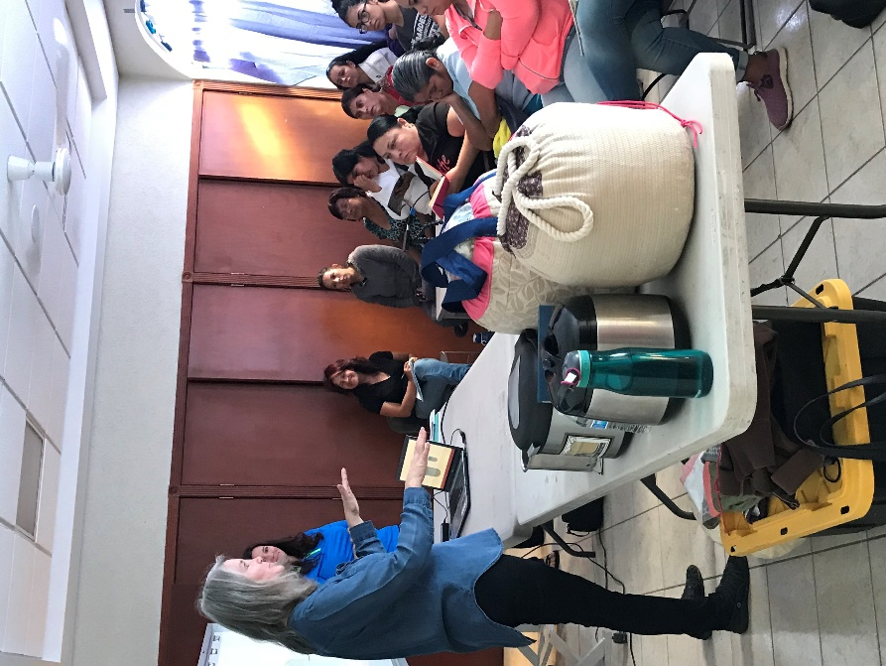Mexico 2017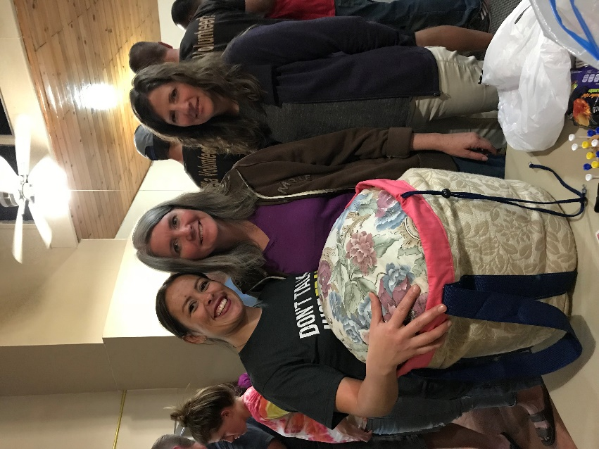
In Mexico, the response to the retained heat cooking class was beyond anything I could have ever hoped. When I started discussing fuel savings and preparing the dry beans I brought to share with them with only a 10 minute boil - the room was a buzz! All I could hear was “gas” “gas”. Savings on fuel costs is a huge deal for them! Beans usually take 3 hours to prepare.

On a more local level we are implementing the HopeSac Program - Hope Service and Charity.
Thyme for Hope - A Thermal Cooking Class. Help others discover the benefits and simplicity of thermal cooking, update on the HopeSaC project and raise funds to benefit CaringwithCookers.org.
Thyme for Service - These events give others the opportunity to be involved by cutting, pinning, sewing and assembling HopeSaC kits.
Thyme for Charity - Is for those receiving the HopeSaC’s. They have the opportunity to receive instruction, and then finish assembling HopeSaC kits for their personal use.

Here are some ways to get involved:
1 - Host or attend a Thyme for Hope Retained Heat Cooking Class.
2 - Attend or host a Thyme for Service event. Help make HopeSaC Cookers for Charity - There are several ways to help whether you are close or live at a distance.
3 - Organize Thyme for Service events in your area.
4 - Sew HopeSaC components from home and send them in, we will make up the kits and get them to those in need.
3 - Share the HopeSaC story with others, invite them to help.
4 - Your donations of any kind, whether monetary or of supplies, are always appreciated.

More information can be found at the following:
www.caringwithcookers.com
www.thermalcooking.net
Facebook: HopeSaC Cookers and Let’s Make Sense of Thermal Cooking Cookbook
letsmakesenseof@gmail.com

Thanks, Cindy
801-979-3820
© 2017 Cindy Miller

